Week 5 – air
air | airport | airfare
bairn | armchair | hairdresser
chair | fairy | millionaire
fair | repair | despair
pair | airplane | staircase
stair | haircut | airflow
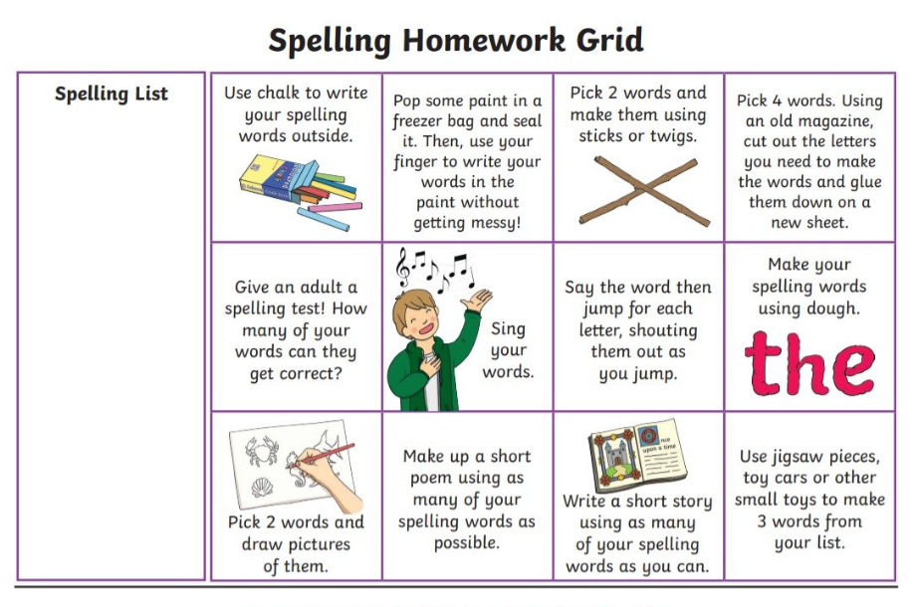

Maths and Numeracy
Focus Area | Learning Intention (Es & Os) | Home-Learning Suggestions | Specific Tasks for Practice
Count On & Count Back | I am learning to add and subtract using count-on and count-back strategies. | Use everyday counting: steps, stairs, or jumps in the garden. | Start at 12 and count back 5. Start at 7 and count on 8. Record the totals.
Number Bonds to 20 & 100 | I can recall and use number bonds to 20 and 100 to solve problems. | Play “Make 20” or “Make 100” with cards or dice. | Roll two dice and find what’s needed to make 20. Write three pairs that make 100.
Doubles & Near Doubles | I can use doubles and near-doubles to add quickly. | Spot doubles around the house (pairs of shoes, cups, etc.). | Write 5 double facts (e.g. 6 + 6 = 12). Then try near-doubles (e.g. 6 + 7 = 13).
Add and Subtract Tens & Units | I can add and subtract tens and units mentally. | Use prices or weights on packets to practise adding/subtracting tens. | 45 + 30 = ? 76 − 40 = ? Try three more of your own.
Three-Number Addition | I can add three numbers together efficiently. | Use page numbers or house numbers to create sums. | Choose three numbers and add them. Can you find a quicker way?
Real-Life Problem Solving | I can apply mental strategies to real-life contexts. | Use shopping receipts or toy prices to estimate totals. | “You buy items costing £12, £8 and £5. How much altogether?” Try changing one price.
Outdoor Maths | I can use mental strategies outdoors to reinforce number sense. | Collect natural materials and group them. Add or subtract quantities. | “You have 7 stones, your friend has 9. How many altogether?” “Take 3 away – how many left?”
Games & Challenges | I can use games to strengthen mental agility. | Play online games like Hit the Button or Loop Cards. | Time yourself: how many correct answers in 2 minutes? Try to beat your score tomorrow.

Game Title | Focus Area | Link | Suggested Use at Home
Hit the Button | Number bonds, doubles, missing numbers | https://www.topmarks.co.uk/Flash.aspx?f=HitTheButtonv11 (topmarks.co.uk in Bing) | Play for 2 minutes daily — aim to beat yesterday’s score.
Loop Cards | Addition and subtraction within 20 or 100 | https://www.topmarks.co.uk/Flash.aspx?f=loopcardsv6 (topmarks.co.uk in Bing) | Choose “Addition Within 20” or “TU + U” for quick mental practice.
Bingo – Addition | Adding single- and two-digit numbers | http://www.wmnet.org.uk/resources/gordon/Bingo%20-%20addition.swf | Play together — first to complete a line wins.
Bingo – Subtraction | Subtracting within 10 or 100 | http://www.wmnet.org.uk/resources/gordon/Bingo%20-%20subtraction.swf | Use mental subtraction strategies to find answers quickly.
Catapult Count On | Counting on to the next decade | http://www.ictgames.com/catapultCountOn/index.html | Work out how many to reach the next 10 — knock down the castle!
Bridging Through 10 | Addition bridging strategy | http://www.ictgames.com/bridging.html | Practise jumping to 10 first — rocket blasts off when correct.
Brilliant Beadstring | Visual addition/subtraction with beads | http://www.ictgames.com/brilliant_beadstring_with_colour.html | Use beads to show jumps of 5 or 10 — great for visual learners.

